| **Test Name** | | | Check leader board | | | |
| --- | --- | --- | --- | --- | --- | --- |
| **Use Case Tested:** | | | Check Leader board | | | |
| **Test Description:** | | | Leader board screen should display ten top scores | | | |
| **Pre-conditions** | | | User must have logged in  Menu screen must be open screen | | | |
| **Post-conditions** | | | User should be able to see top 10 scores plus their own if not in top 10 | | | |
| **Notes:** | | **Shows top 10 but the 10th is nearly off the screen noteworthy.** | | | | |
| **Result (Pass/Fail/Warning/Incomplete)** | | **Pass** | | | | |
|  | **TEST STEP** | | | **EXPECTED TEST RESULTS** | P | F |
|  | User clicks Leader board button on menu page | | | Should show Leader board screen with top 10 scores plus their own if not in top 10 | P |  |

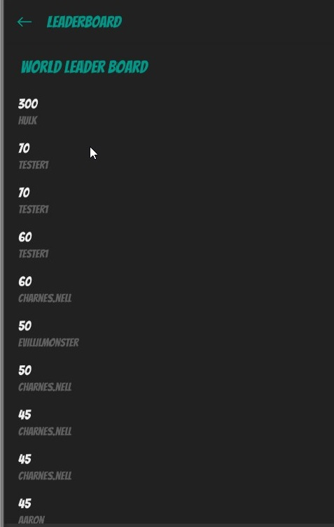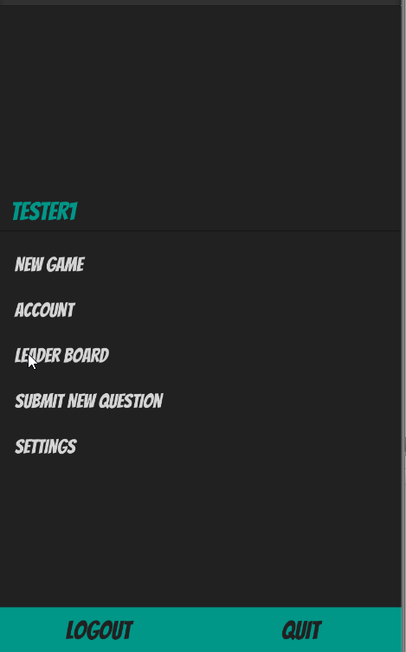

Pressing Leader board button Shows top10 scores